Q1. A vegetable oil can be extracted from olives.
(a) The diagram shows the first step in this extraction.
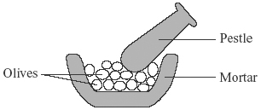
Use the correct word from the box to complete the sentence about this first step.
evaporating | filtering | pressing
The olive oil is extracted by ................................................................... the olives.
(1)

(b) The contents from the mortar are tipped into a beaker. The mixture is left to settle.
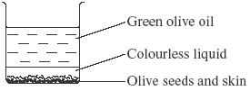

(i) What is the name of the colourless liquid?
...........................................................................................................................
(1)

(ii) How can the olive seeds and skins be removed from the liquids?
...........................................................................................................................
...........................................................................................................................
(1)
(Total 3 marks)

Q2. The label on a bottle of salad dressing shows that the dressing contains the following ingredients.

Ingredients
Water  Vegetable oil  Egg yolk  Sugar  Flour  Vinegar  Salt | Extract of spices  Preservative E202  Emulsifier E405
(a) One of the main ingredients in salad dressing is vegetable oil.

(i) Use the correct word from the box to complete the sentence about the extraction of vegetable oil.
crushed evaporated hardened
To extract the vegetable oil, the fruits or seeds of plants are first
......................................................... .
(1)

(ii) The liquids can be separated from the solid parts of the fruits or seeds by filtering.
Suggest one reason why separation by filtering is better than separation by distilling.
.........................................................................................................................
.........................................................................................................................
(1)

(b) (i) A mixture of vegetable oil and water is shaken and left to stand for several minutes. The diagram shows the result.
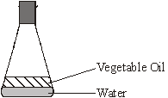
Complete the following sentence.
The vegetable oil and water .................................................................................... .
(1)

(ii) A mixture of vegetable oil, water and egg yolk is shaken and left to stand for several minutes.
The diagram shows the result.
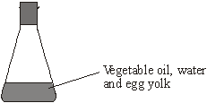
Use words from the box to complete the sentence.

additive distil emulsion extract mix separate
The egg yolk causes vegetable oil and water to ........................................................
and form an ..................................................... .
(2)
(Total 5 marks)

