The new build is coming soon!
Ecological consultants have checked out the site and found a great crested newt!
Write a letter to Mr McMillan to explain:
- The importance of great crested newts
- How the new build may impact their population
- What the school could do to prevent the newts from dying out

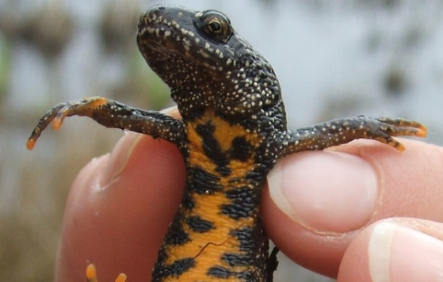

Background
Great crested newts are a protected species in the UK because there are so few of them and populations are gradually declining. Surveys often need to be taken at sites which are going to be built on to check whether great crested newts exist. If the do exist, building on their habitat may cause habitats to be lost, habitats to change, habitats to become isolated (so newts cannot move between sites).
Construction should minimise the effect of building on their habitat. New habitats may need to be created for them, or the newts may have to be moved to a different site.
Newt’s habitat
Great crested newts use both water and land habitat. Great crested newts prefer small to medium sized ponds, rather than garden ponds or lakes. Breeding ponds must usually support water vegetation (e.g. reeds) to provide a structure for egg laying. Open, largely un-shaded ponds are preferred over heavily shaded ponds. Ideally there should be open, less grassy areas within the pond to allow adult males to display in clear view of females. Great crested newts tend to avoid ponds with fish.
Land habitat must provide permanent areas of refuge habitat for shelter, daytime refuges and movement opportunities. For hibernation, newts seek out a location that affords them protection from winter conditions and exploit natural opportunities within the landscape such as log piles, disused mammal burrows or cracks in the ground or artificial opportunities such as cellars, brick/rubble piles, rather than excavating their own sites.

