GCSE ISA Homework

- Match up the term to its definition.

Independent variable |  | The variable that you measure in an experiment.
Dependent Variable |  | The maximum and minimum values of the dependent or independent variable.
Control Variables |  | If the investigation is repeated by another person and the same results are obtained.
Reproducible |  | The variable that you change in an experiment.
Resolution |  | A variable that may affect the outcome of the experiment, so must be kept the same during in an experiment.
Range |  | This is the smallest change in the quantity being measured of a measuring instruments that gives a clear change in the reading.

- A preliminary experiment works out an appropriate value for a control variable.

Example: You are investigating how mass of water affects temperature rise.
Control variable: | Size of beaker
Size of beaker you could use: | 100ml, 250ml, 400ml
I would pick the size of beaker that: | Heats water 20ºC the quickest

a) You are investigating how length of exercise affects heart rate.
Control variable: | Type of exercise.
Types of exercise you could use:
I would choose the exercise that…

b) You are investigating how the number of hamburgers eaten affects the mass of a person.
Control variable: | Make of hamburger.
Makes of hamburgers you could use:
I would choose the hamburger that…

c) You are investigating how ***.
Control variable:
Types of exercise you could use:
I would choose the exercise that…

- Write a simple conclusion for these 3 graphs. e.g. As the length of exercise increases, heat rate increases.
 | 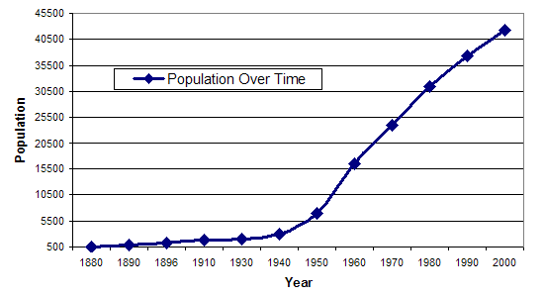 | 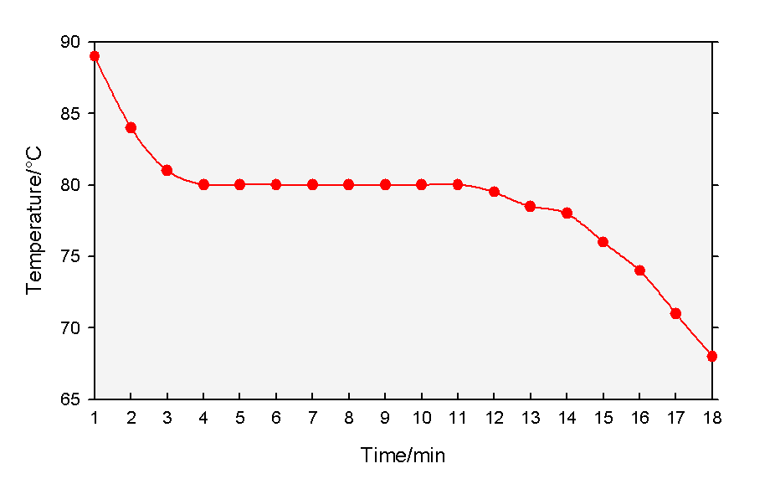
Conclusion:  As the voltage increases _______  ____________________________  ____________________________ | Conclusion:  As time increases _____________  ____________________________  ____________________________ | Conclusion:  ____________________________  ____________________________  ____________________________

4) You did an experiment to investigate how the size of a solar cell exposed
to light affected the voltage (amount of electricity) produced.
a) These were your results:
Size of solar cell (cm²) | Mean output voltage (millivolts) | Write a conclusion for your data:  As the size of solar cell ________________________________  ___________________________________________________  ___________________________________________________
10 | 80
15 | 110
20 | 150
25 | 200
30 | 230
35 | 270

b) Here are someone else’s results:
Size of solar cell (mm²) | Mean output voltage (millivolts) | Do they show the same trend?  - Yes/No (circle one)  - Because_________________________________________________  - Two pieces of data that back this up are_______________________  ________________________________________________________
6000 | 8000
5000 | 7600
4000 | 7140
3000 | 6800
2000 | 6360
1000 | 5900

c) Here are someone else’s results:
Do they show the same trend?
- Yes/No (circle one)
- Because_________________________________________________
- Some data to back this up is ________________________________
________________________________________________________

