Q1. Olive oil is used to make salad dressings and margarine.
(a) Vinegar is often used to make salad dressings.
Vinegar contains 95% water and 5% ethanoic acid.
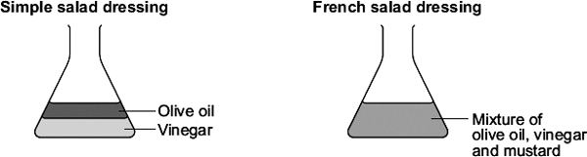
To make a simple salad dressing add olive oil to vinegar and shake. After a few minutes the mixture separates.
To make a French salad dressing add mustard to the olive oil and vinegar and shake.
After several minutes the mixture does not separate.
(i) Why does the mixture in the simple salad dressing separate?
...............................................................................................................
...............................................................................................................
(1)

(ii) Mustard in the French salad dressing has molecules with hydrophilic properties and hydrophobic properties.
Explain why the French salad dressing does not separate.
You may include a diagram to help you to answer this question.
...............................................................................................................
...............................................................................................................
...............................................................................................................
...............................................................................................................
...............................................................................................................
...............................................................................................................
...............................................................................................................
...............................................................................................................
(3)

(b) Olive oil contains 89% unsaturated fats and 11% saturated fats.
What is the test and the result for unsaturated fats?
........................................................................................................................
........................................................................................................................
........................................................................................................................
........................................................................................................................
(2)

(c) Olive oil is hardened to make margarine.
Describe the reaction and conditions needed to harden a vegetable oil.
........................................................................................................................
........................................................................................................................
........................................................................................................................
........................................................................................................................
(3)
(Total 9 marks)

