Q1. The diagram shows the structures involved in a reflex action.
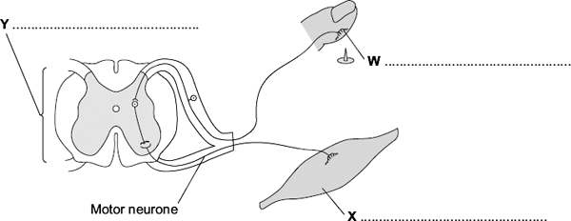
(a) On the diagram, name the structures labelled W, X and Y.
(3)
(b) The control of blood sugar level is an example of an action controlled by hormones.
Give two ways in which a reflex action is different from an action controlled by hormones.
1 .....................................................................................................................
.......................................................................................................................
.......................................................................................................................
2 .....................................................................................................................
.......................................................................................................................
.......................................................................................................................
(2)
(Total 5 marks)
Q2.Squirrels live in woodland.
Table 1 shows: the total area of England, Scotland and Wales and the area of different types of woodland in these countries.
Table 1
Country | Total area of  country in  thousands of km² | Area of woodland in thousands of km²
 |  | Coniferous  woodland | Broadleaf  woodland | Total
England | 130 | 3.6 | 7.8 | 11.4
Scotland | 79 | 10.4 | 3.0 | 13.4
Wales | 21 | 1.9 | 0.9 | 2.8

(a) Look at the data for the three countries. Estimate which country has the greatest proportion of its area suitable as a habitat for squirrels.
Support your answer with relevant figures.
.......................................................................................................................
.......................................................................................................................
.......................................................................................................................
.......................................................................................................................
.......................................................................................................................
.......................................................................................................................
(2)
(b) The maps show the distribution of grey squirrels and red squirrels in England, Scotland and Wales.
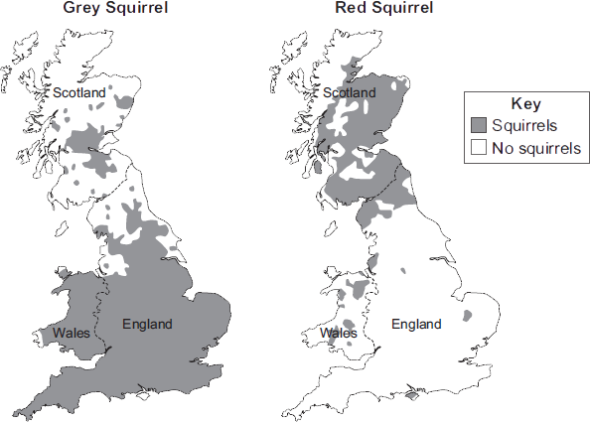
Scientists suggested that the distribution of grey squirrels and red squirrels is linked to the type of trees in woodlands.
(i) The information for England and Scotland supports this suggestion.
How?
..............................................................................................................
..............................................................................................................
(1)

(ii) Give one piece of evidence that contradicts this suggestion.
..............................................................................................................
..............................................................................................................
(1)
(c) Red squirrels are native to the UK.
Grey squirrels were introduced to the UK from the USA over 100 years ago.
Table 2 gives information about the two types of squirrel.
Table 2
 | Grey squirrel | Red squirrel
Population in UK | 2.5 million | 140 000
Main food types | Seeds, nuts, tree bark, birds’ eggs, young birds | Cones from coniferous trees, nuts, tree bark, berries
Health | Can become immune to parapox virus | Cannot become immune to parapox virus
Reproduction | Up to 9 young, twice a year | Up to 6 young, twice a year
Survival rate of young in mixed populations | 41 % | 14 %
Length of life | 2 – 4 years | Up to 7 years
In most parts of the UK the population of grey squirrels is increasing, but the population of red squirrels is decreasing.
Suggest why.
Use information from Table 2.
.......................................................................................................................
.......................................................................................................................
.......................................................................................................................
.......................................................................................................................
.......................................................................................................................
.......................................................................................................................
.......................................................................................................................
.......................................................................................................................
(3)
(Total 7 marks)

Q3. (a) List A gives the names of three stages in trialling a new drug. List B gives information about the three stages. Draw a line from each stage in List A to the correct information in List B.
List A  Stage |  | List B  Information
 |  | Used to find if the drug is toxic
Tests on humans
including a placebo
The first stage in the clinical trials
of the drug
Tests on humans using
very small quantities of
the drug
Used to find the optimum dose
of the drug
Tests on animals
Used to prove that the drug is
effective on humans
(3)
(b) Read the passage.
Daily coffee dose delays development of Alzheimer’s in humans.
Alzheimer’s is a brain disease that causes memory loss in elderly people.
Scientists studied 56 mice that had been genetically engineered to develop Alzheimer’s.
Before treatment all the mice did badly in memory tests.
Half the mice were given a daily dose of caffeine in their drinking water.
The dose was equivalent to the amount of caffeine in six cups of coffee for a human.
The other mice were given ordinary water.
After two months, the caffeine-drinking mice did better in memory tests than the mice drinking ordinary water.
The headline for the passage is not justified. Explain why as fully as possible.
.......................................................................................................................
.......................................................................................................................
.......................................................................................................................
.......................................................................................................................
.......................................................................................................................
.......................................................................................................................
(3)
(Total 6 marks)

